Photograph Permission Form
As part of GDPR legislation, we are required to obtain your permission to use photos and video for the purposes of participation in and promoting the More to me than HIV exhibition, and for archive purposes.
You have the option to refuse permission for your images to be used in certain ways.
There are further notes on the use of your images and your privacy on the following page
Please choose YES or NO for the following permissions
YES / NO I am over the age of 18, and I give permission for my photographs to be part of the More to me than HIV exhibitions for Brighton and Hove Libraries
Please be aware that the exhibition may be displayed in the windows of Jubilee Library Brighton, and also the satellite libraries such as Whitehawk, Saltdean etc.
YES / NO I give consent for my images to be used in the satellite libraries
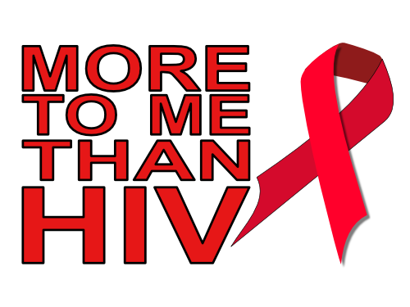
YES / NO The self-portrait and descriptive images I am contributing are not the copy right of any other professional or organization.
info@moretomethanHIV.life
Website: www.moretomethanHIV.life
I give permission for my images to be used on
YES / NO More to me than HIV website
YES / NO More to me than HIV videos/animations on YouTube
YES / NO More to me than HIV posters and flyers
YES / NO More to me than HIV Facebook page
YES / NO More to me than HIV Twitter account
YES / NO Printed articles about More to me than HIV, (e.g. Scene magazine)
YES / NO Please add my E-Mail address (below) to the More to me than HIV E-Mail mailing list (http://eepurl.com/g6ZuvL)
(If the images are the work of a professional or organization, please contact us via info@moretomethanHIV.life, so we may seek to obtain permission to use them from the copy right owner.)
This form is valid for five years from the date of signing. The consent will automatically expire after this time. We will not re-use any images after this time.
PRINTED NAME (OR ALIAS) ____________________________________

SIGNATURE _______________________________ DATE ______________
EMAIL (Optional) ________________________________
Use of photos
Photos will be used to promote the project and in the exhibition. This may be in print, on the internet or on social media. These photographs are submitted by you in a voluntary capacity and no payment changes hands.
Storage of photos
Photos will be stored on a secure hard drive. They will be shared with those responsible for the project through various means (email or online file sharing facilities).
Your photos will be assigned a serial number and your name or alias will not be a part of the file names or assigned to any image.
After this, the photos will be kept by More to me than HIV for longer term storage and archiving, until the project closes, or five years, whichever is sooner.
Privacy
More to me than HIV will not identify you in the photos that you give permission for us to use. However, we may ask you to provide us with a paragraph about yourself which we would like to use in the physical exhibition in the library. Your story may be used to inspire others and break down stigma related to HIV.
A digital copy of this signed permission form will be kept with the photos at all times. As the subject of the photos, you have the right to change your permission to have your photo used in the project.
If you decide that you wish to remove your permission, More to me than HIV will delete your photos securely so they cannot be retrieved after erasure. If photos have already been used for publicity, they are already in the public domain and can no longer be removed.
More to me than HIV will take all steps to ensure these images are used solely for the purposes they are intended. If you become aware that these images are being used inappropriately, you should inform More to me than HIV immediately.

